**Kerjakan Soal berikut ini dengan benar**

1. Make a program using Matlab or Python according to the term

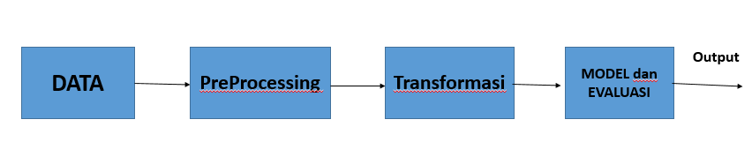

1. Preprocessing is used to determine outliers and missing values. If the data contains missing values ​​and outliers, then handling missing values ​​and outliers.
2. Data transformation. The normalization method according to terms.
3. Split data according to terms.
4. Classification process on the training data using Decision Tree or Naive Bayes.
5. Evaluation using data testing. The evaluation used is the Confusion Matrix.
6. Calculated accuracy of testing dat from confusion matrix. The accuracy formula used follow is:

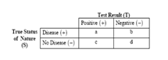

Accuracy = $\frac{a+d}{a+b+c+d}$